Instructions for beamformer

The beamformer will take one or more of the processed data files and create time-vs-angle plots of the arriving waves, using 8 channels (actually 7, since channel 4 is broken) of hydrophone data from the array. The dialog below shows the main steps in the dialog.

>> beamform_band_data

%(prints a list of current files available to the beamformer:)

1 20030701T130229_band_1_sig_7.mat
2 20030701T140426_band_1_sig_7.mat
3 20030701T193401_band_1_sig_7.mat

stack plots (default 0) 1 %if 1, multiple plots over 9 pings or over geotime are stacked in a
single figure, otherwise individual figures.
display titles on figures (default 0) %if 1 graphs are titled, otherwise no titles.
long geotime (default 0) %if 1, files are grouped across geotime (ping 1 is used), otherwise,
a single geotime is used and pings are chosen below.
enter file number (default 25) 1 %pick file for analysis
enter xmission numbers (range 1-9) (default 1) 1:2:9 %choose a subset of the 9 pings available
(can be range as shown, or [1 4 7], etc.)
1

%at this point, a plot is displayed showing energy in the pulse. Choose a frequency range by clicking two points. This is used to choose energy between noise peaks, as shown below.

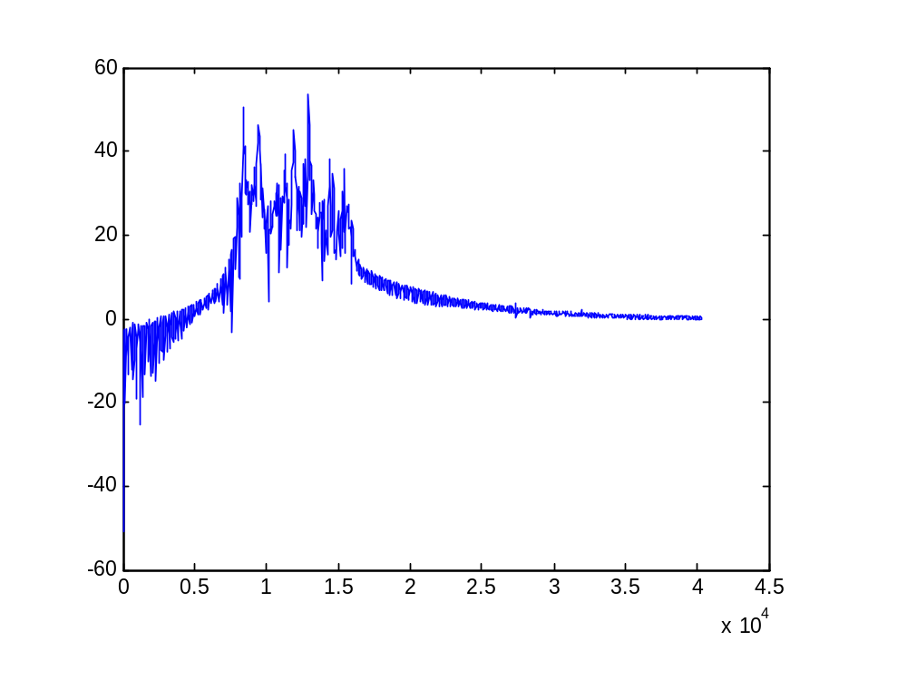
The bar shown in the figure represents two points that are clicked (only the x coordinate is used) to isolate the band used for processing. The peaks shown above are unwanted artifacts from the recording equipment. If one of the peaks is included in the band, a spurious return may be visible.

click 2 points for min and max frequency then hit return

%after the two points are clicked, processing continues on all pings chosen.

2
3
4
5

%at this point, the plot is displayed.

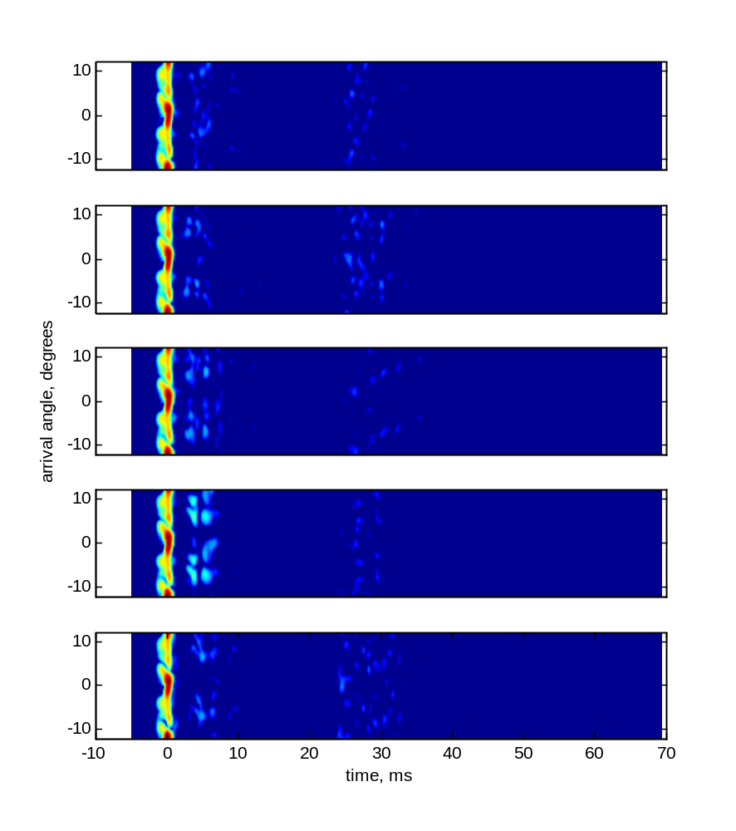

If the “stack” option is chosen, the prompt below appears asking if the user wants to change the horizontal scale. If so, entering the lower and upper x limits will result in a scale change to show parts of the arrival picture better.

enter time scale, e.g., [5 20] or [] to quit (default [5..20]) [-2 10] %changes time scale
enter time scale, e.g., [5 20] or [] to quit (default [5..20]) [] %empty vector quits

